Wine Connoisseur's Final Paper

CIS 8395 Big Data Experience

Naomi Kouassi

Janay Riza

Paul Afram

**Business Problem**

People enjoy a glass of wine for many different reasons. Whether it is a perfect addition to a savory meal or a refreshment before relaxation, wine has become a household necessity. Wine, “an alcoholic beverage made with the fermented juice from grapes”, can be classified as either red or white and sweet or dry. Although there are various combinations of red and white wine, there are ten popular wines often bought by consumers. White wines include Chardonnay, Riesling, Pinot Grigio and Sauvignon Blanc. Red wines include Cabernet Sauvignon, Pinot Noir, Syrah, Zinfandel, Malbec and Merlot all in which are known for their exclusive taste. The options are limitless.

The question we pose is how can a person determine what wine pairs best with a specific food? We have completed research on why certain wines pair best with certain foods and the relationship between acidity, tannin, and taste. This project allowed us to create a recommendation system that pairs wine with food. The success of this recommendation system will allow consumers to make informed decisions when creating and indulging meals. In addition to making informed decisions, understanding the pairing between wine and food also allows chefs and restaurant owners to enhance the flavors of their meals. Food pairing can be recognized as a subjective matter but the ingredients within food and wine does create complimentary flavor amongst one another, forming a satisfactory meal.

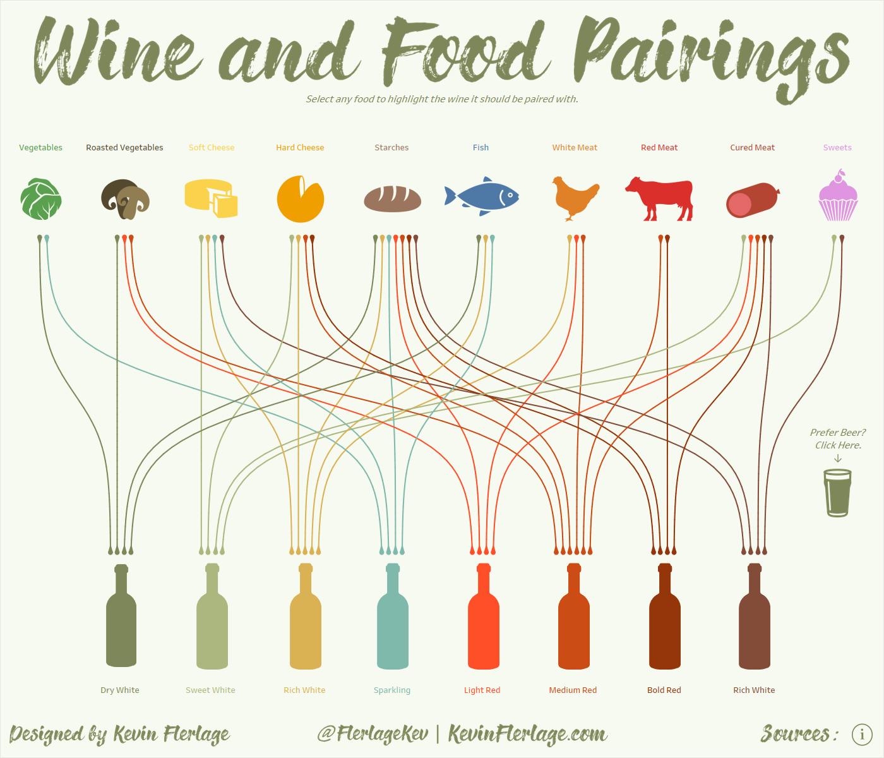

As previously stated, acidity, tannin, and taste are commonly used to determine which wine pairs best with a specific food. People are naturally drawn to flavor, whether their beverage is sweet or dry. Personal preferences are initially what encourages people to choose their wine rather than their understanding of a wine that would pair best with what their indulging. Each wine has a specific amount of acid, tannin and sugar that creates a particular taste. According to one of our sources, “acidity of wine can alter the way we perceive a flavor of wine.” The acidity of wine cuts the saltiness, oil and fat in a dish, creating additional flavor. “Acidity gives wine refreshing, crisp and fresh qualities”, while alluding to the sourness we taste after indulging. In addition to our research, it was discovered that white wines pair best with foods of high acidity for this reason. It will later be discussed why white wine and foods of high acidity pair well together.

Tannin is an important factor in wine and food pairing. It is a polyphenol found in plants, seeds, bark, wood, leaves and fruit skins. Tannin, sourced from grape skins, seeds and stems, is known for its texture or the dry sensation associated when consuming wine. It creates the bitter flavor often found in red wines such as Cabernet Sauvignon and Tannat. Tannin is great for aging wine over time to create “the smooth and less harsh” taste. It was discussed in “Food and Wine Pairing: Art or Science?”, that tannins are associated with the bitter flavor of wine and how it reacts to proteins found in meats and cheese. Wines with high tannin are known to taste smoother when paired with high protein food such as fish, seafood and lean beef. According to “Journal of Wine Research,” tannin is meat’s major ally because tannins help cut through the fat of the meat and red meat. This describes how the wine components, texture and flavor of wine plays a significant role in creating savory meals.

Taste, although a subjective matter, varies from person to person based on their personal preferences. The basic senses or taste of wine includes herbal, fruity and earthy. Food has basic yet specific tastes that are identifiable including sweet, salty, bitter, sour, pungent, etc. For example, the article “Food and Wine Pairing: Art or Science?” states that “sweet wine can we used to balance food that are spicy or tarte.” It also states that sweet wines pairs best with a dish that is hot and has various flavors in comparison to a sweet dish. Taste can be indulged by smell or the perception of the tongue. Identifying the ingredients within both food and wine are key indicators for our recommendation system. The complexity of discovering food pairing in relation to wine is the reason why it can be considered an art or a science.

The image below was taken from an article that contributed to our research of food and wine pairing. The image provides a visual of basic taste components in wine and which taste is more identifiable for each. For example, red wines have more bitterness while white, rosé and sparkling wine have more acidity. Figure 2 displays pairings between various flavors as well as flavor clashes. The datasets and articles used for our research further identifies why certain flavors compliment or contrast with the taste of a meal.

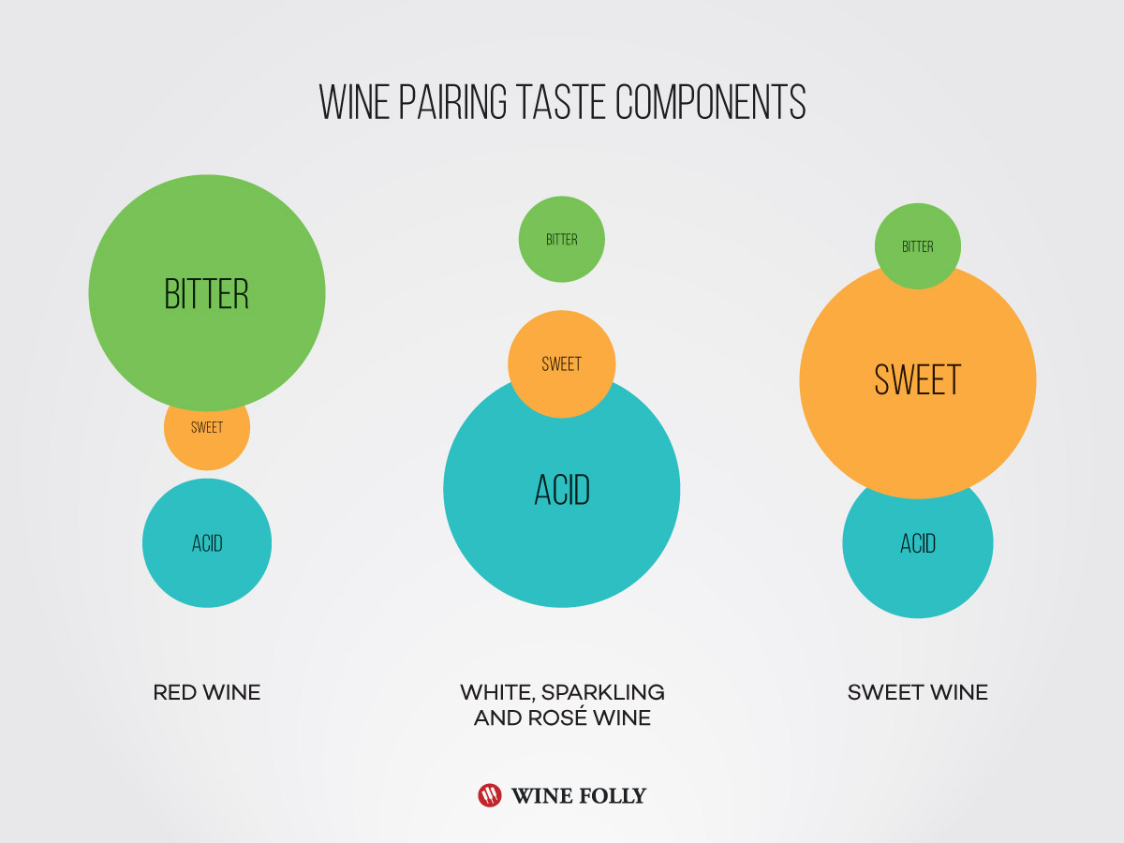 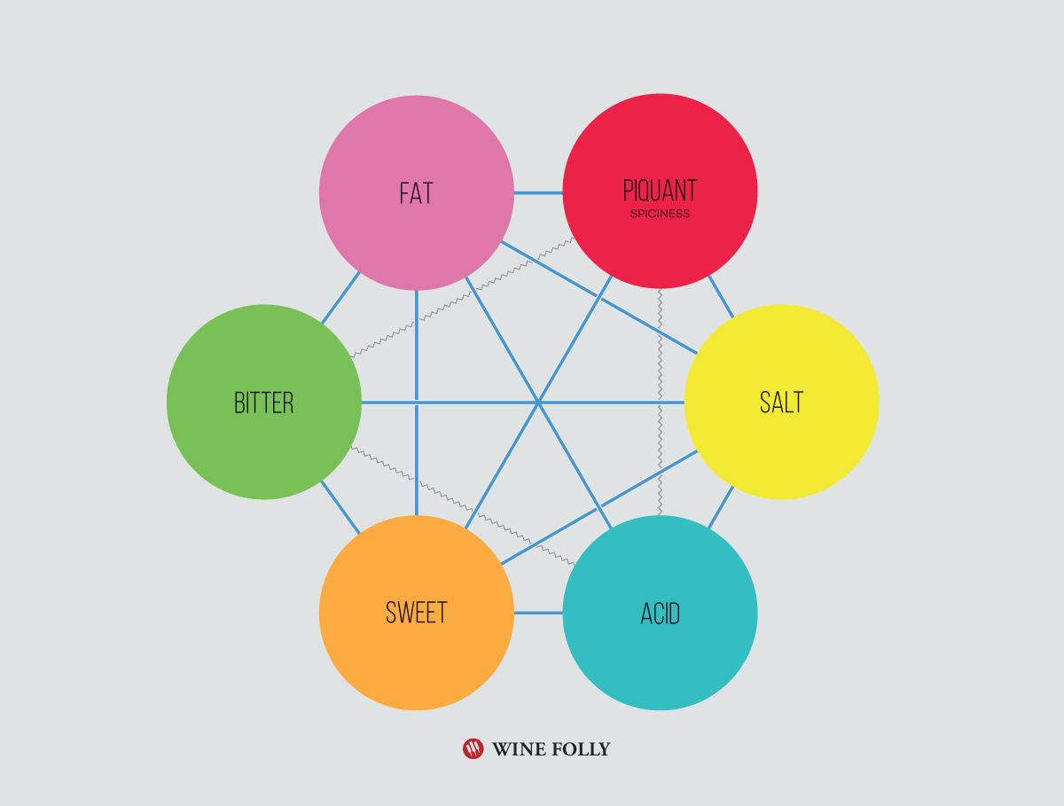

Figure 1 Figure 2

**ETL Process**

The recommendation system will suggest complementary and congruent wine pairings with food based on the acidity of food ingredients and different types of wine from two separate datasets. To create the recommendation system, the data will derive from two data sets from Kaggle. The first dataset is a wine reviews dataset with ten columns and 130,000 rows. The second dataset is a food ingredients and recipe dataset with six columns and 13,500 rows. Below are images on the datasets:

Wine Reviews Dataset:

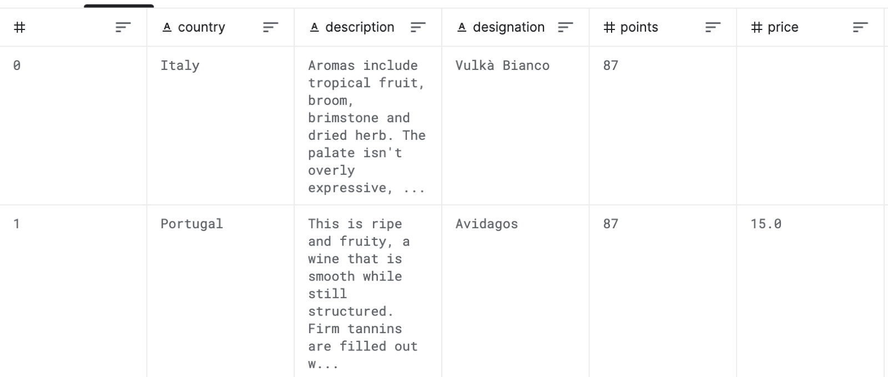

Food Ingredients and Recipe Dataset:

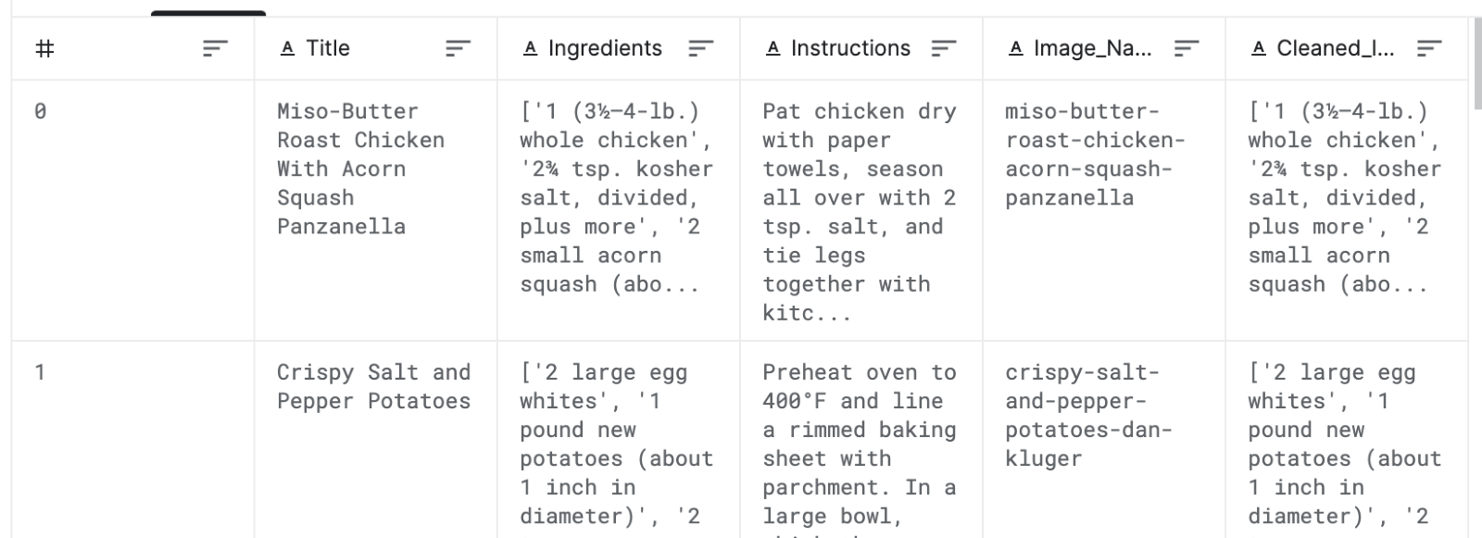

**Data Stitching**

The two datasets do not need to be merged into one dataset in order to create the recommendation system. Our team will follow the ETL process, extract, transform, and loading the data. The data will be extracted from Kaggle, and we will be transforming the data manually. Initially, our team believed merging the two datasets would allow the visualization to display the most displayed words in the dataset, but we realized that we would not be able to decipher which ingredients we were going to compare the acidity levels to. Our team decided the best approach would be to run each dataset separately through the Azure ML process to display the most prominent words in each dataset. If we were to merge the two datasets, the process of us merging the two datasets is called data stitching. It is significant to the ETL process because it is part of the transformation phase. As we were deciding the best approach for the retrieving the most significant data, we realized that data stitching would have not provided us the information we were trying to retrieve for the recommendation system.

**Data Cleaning**

Data cleansing is also part of the transformation phase, and we will need to remove stop words and any other remove unnecessary information from each dataset. We decided to remove words that were not significant, words that were not actual ingredients and that did not have an acidity level, words such as “minced”, “spice”, and “bowl”. Removing those words allowed our team to focus more on important information and focus on comparing the actual ingredients in each dataset. Since we will be comparing the description and ingredients columns from both datasets, our analysis will begin with dropping the columns with that do not include ingredients and columns with numbers, such as the points column in the wine dataset and the instructions column in the food ingredient and recipe dataset. Once we transform the data, we will load the data into Power BI where we will begin the NLP text analysis and display the results of the analysis in a word cloud visualization.

**Analytics**

The machine learning algorithm that will be used to develop the recommendation system is Natural Language Processing (NLP). Natural Language Processing is an approach used to analyze and represent “naturally occurring text at one or more levels linguistic analysis for the purpose of achieving human-like language processing for a range of tasks or applications”. (Liddy 2001). NLP is an unsupervised learning approach. Unsupervised learning is a machine learning approach where the model does not need to be supervised. In unsupervised learning, the model is allowed to work on its own and discover information and this approach usually deals with unlabeled data. We chose this approach because it will allow us to discover different kinds of patterns within the two datasets. Our approach is to use NLP against the description column of the wine dataset and use the ingredients column of the food ingredients and recipe dataset to extract keywords. Our intention is to extract are the words (ingredients) from the description column in the wine dataset and the ingredients columns in food ingredients and recipe dataset in hopes that the ingredients will match together. From there, we will look up the acidity of the ingredients to determine the congruent and complimentary pairings of food and wine.

Since we will be comparing the description and ingredients columns from both datasets, our analysis will begin with dropping the columns that do not have ingredients and have numbers in them. Once we transform the data, we will load the data into Power BI where we will begin the NLP text analysis and displaying the data in a word cloud visualization. Our choice of the Power BI tool stems from the fact that the tool allows you to run all the machine learning algorithms that one can run in Python, R and Azure ML, thus allowing us to run the process in one tool and then integrate to transfer the data to another tool for visualization. Our analysis would be considered predictive analytics because we are predicting the pairings based off the analysis of the word cloud.

**Visualization:**

The data will be displayed in a word cloud visualization in Power BI. We chose to use the word cloud approach as a means of identifying which ingredients and flavors are used in the description column of the wine reviews dataset and the ingredient column in the food ingredient and recipe dataset. The world cloud will display the words (ingredients) based on the frequency of the word (ingredient) in each dataset and our team will be to decipher which word (ingredient) was frequent in the datasets based of the size of the word in the word cloud. During our analysis, we noticed that the description column in the wine reviews dataset displayed different types of wine, such as merlot, in the word cloud. Our initial hopes of having the word clouds display similar ingredients was not possible based off the results of the analysis. We decided to switch our approach instead to take the top five ingredients from the food ingredient and recipe dataset and compare the acidity levels of the wine types displayed in the word cloud and the acidity level of the ingredients. We decided to take this approach instead because through research, we discovered wine can be paired based on acidity/ ph level and acidic foods should be paired with acidic wine.

**Below are the steps taken to load the data into PowerBI:**

In Power BI click on the three dotted line on the right-hand side to connect to the marketplace where you can download the word cloud visual

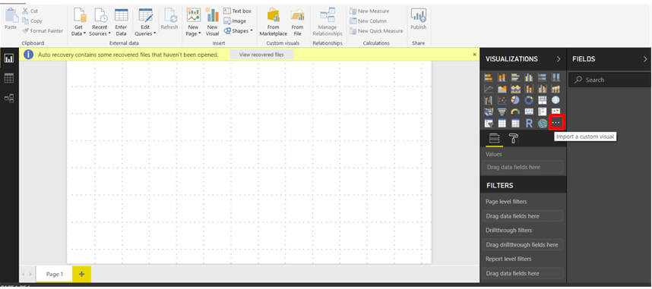

Next click import from the marketplace and then connect to the marketplace

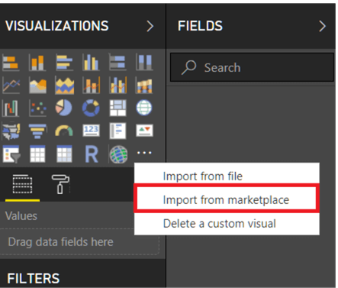

Signing-in gets you connected to the Power BI visuals marketplace 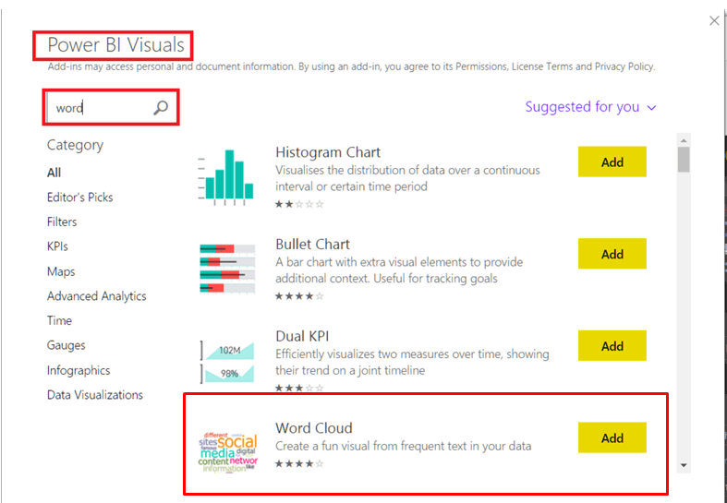

Then click add to add the word cloud visual to the Power BI visuals.

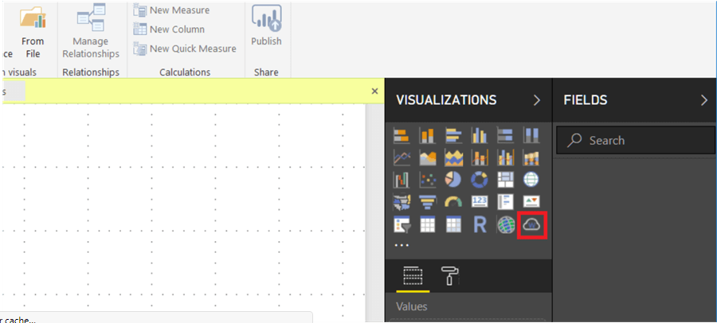

The next step is to import your dataset into Power BI desktop. For the purpose of this research, we will use a text/csv file format

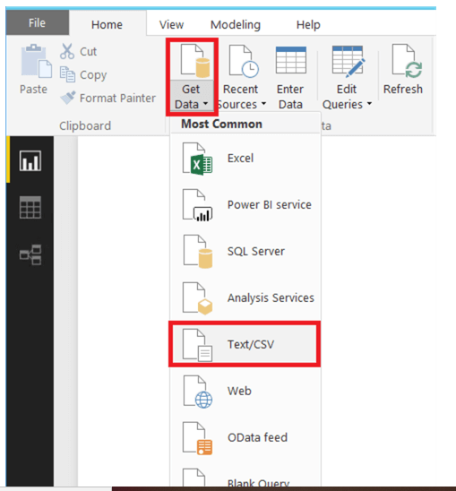

This should connect you to the data source where you select your file and click open.

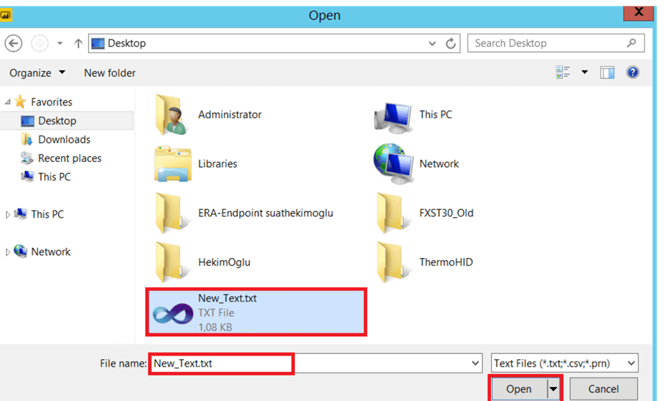

Once data appears in the Power BI desktop click Load

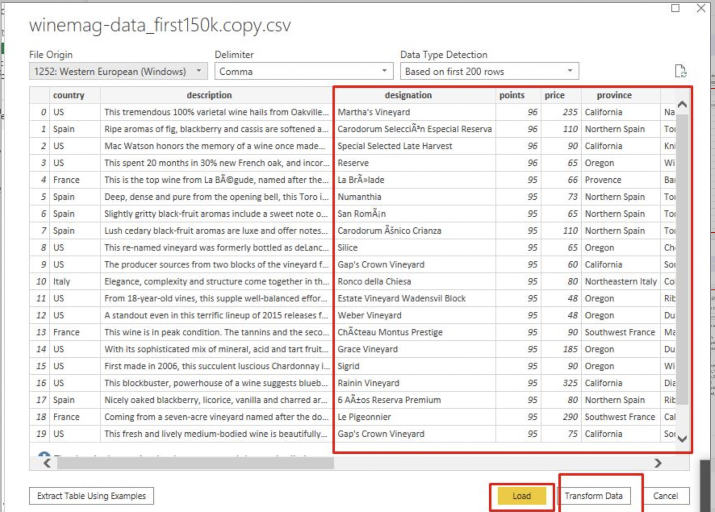

Next click on remove columns for a list of the columns and un-select the insignificant columns and then click OK.

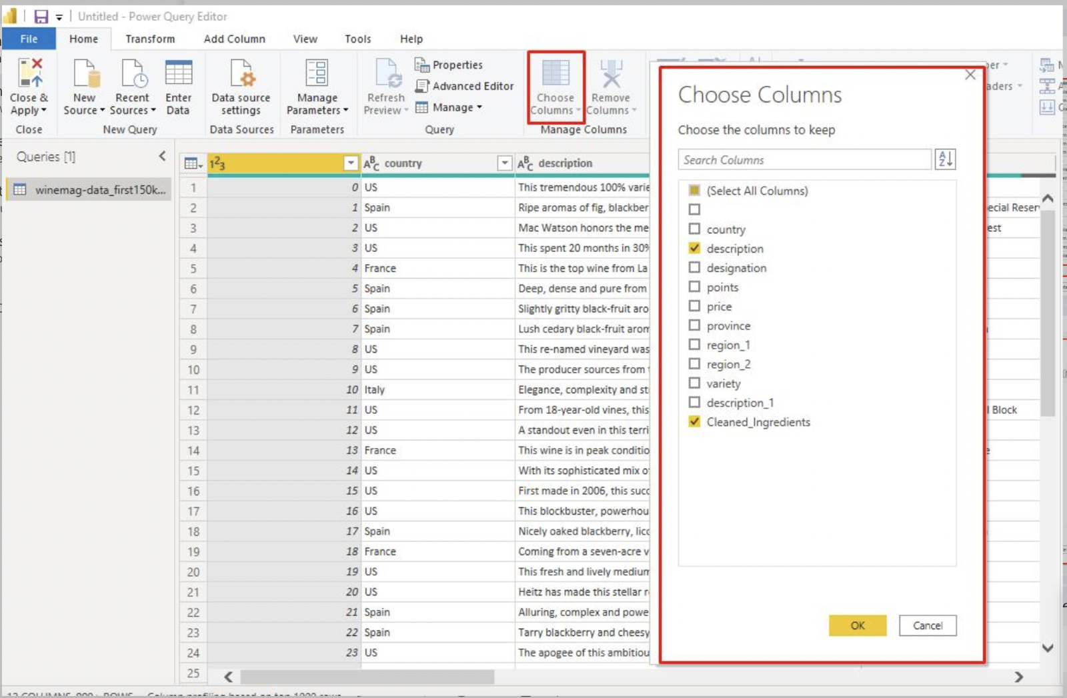

Once complete select columns on the right-hand side in the **Fields section** to be applied to word cloud or drag and drop them into the **Values Section** to provide a summary of the data and its word count.

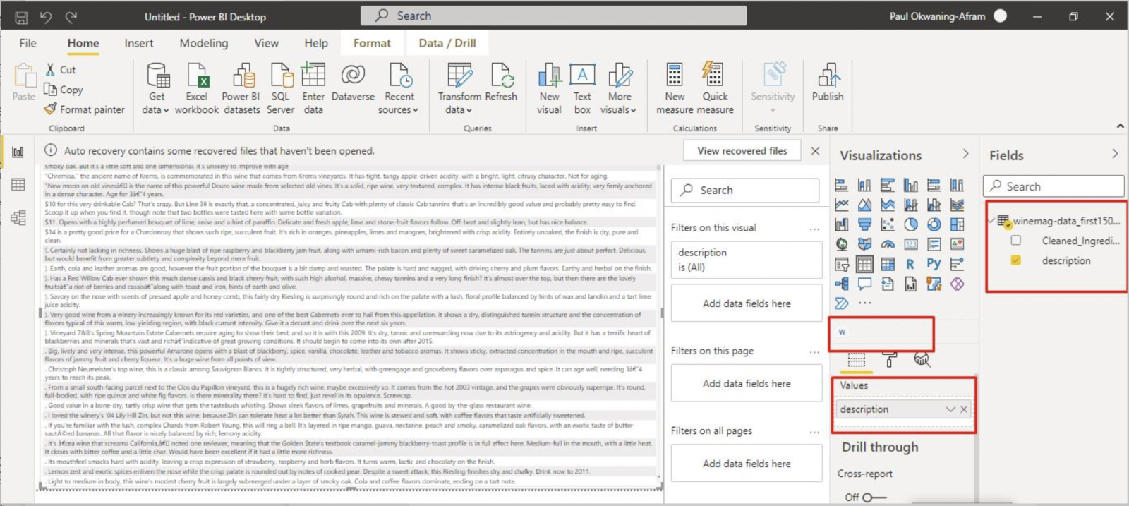

Once complete look to the right and side in the **Fields section** to select the column needed to be applied to word cloud or drag and drop them into the Values and Category section to provide a summary of the data and its word count.

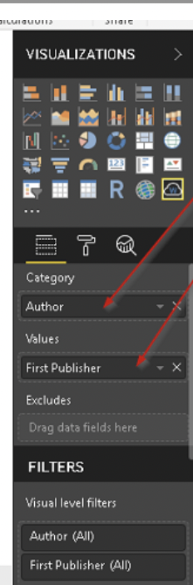

Next, click on Word cloud icon to convert the selected column(s) into a word cloud.

The bolder words represent words with a high frequency of occurrence.

Repeat these steps from both the Wine dataset and the ingredients datasets.

Word cloud for Wine Reviews Dataset:

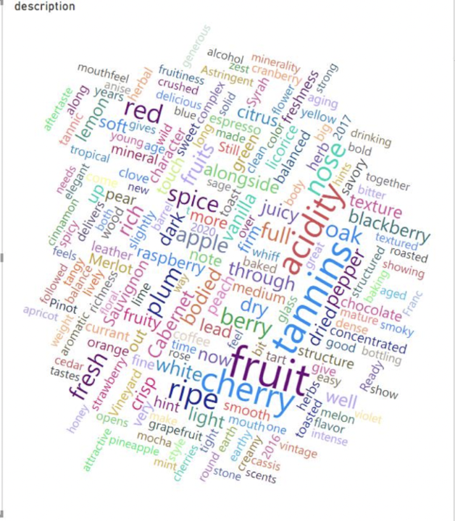

Word cloud for Food Ingredients and Recipe Dataset:

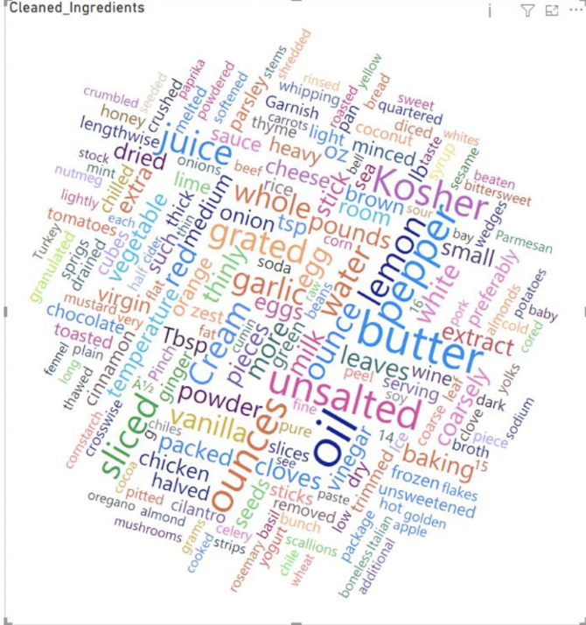

**Challenges**

Creating a recommendation system that pairs a wine with specific food posed several challenges to the group. We asked ourselves a series of questions to help us identify a plausible relationship between wine and food. One challenge we faced as a group was finding two separate datasets that contained enough information including common ingredients and customer reviews for wine and food. After locating the two datasets that contained the necessary information, we had to clean the data by removing unnecessary columns in order to merge the two large datasets. It was necessary to find two large datasets to ensure that our findings were sufficient to create a thesis. This led to our second challenge which was to find the relationship between the food and wine datasets. As previously stated, the first dataset contained 10 columns and 130,000 rows with wine information and the second dataset contains 6 columns and 135,000 rows of food information. Reading several articles from both food experts and wine enthusiast provided some insights on the ingredients between wine products and food products and the reasoning behind the pairing. This identified an additional challenge which included building the pairing between the two datasets, food and wine, which in term was our biggest challenge. The acidity of both wine and food was imperative in determining an appropriate relationship. Unfortunately, we were unable to find a dataset that contained food acidity and wine acidity. As a result of this, we had to complete additional research on the acidity and the PH levels of the top five words within the food and wine dataset to determine a relationship. Once gathering the acidity levels of the chosen words, we came up with complimentary pairings. We also found that the ingredients and taste columns were imperative to determining the best approach in deciding an appropriate machine learning algorithm. Deciding the best machine learning algorithm became a challenge because we wanted to find the best method for identifying the relationship between food and wine. After observing the information, we gathered, we chose to use Natural Language Processing, NLP, for our recommendation system. Our approach is to use NLP by using the description column in the wine dataset and to utilize the ingredients column in the food dataset.

**Pairing examples**

Our research provided us with several reasons on why certain wines are paired with specific foods. As mentioned previously, taste and flavor based on the acidity and tannin of a wine, are what is used to create a delicious pairing. One of the few pairs we discovered was sparkling rosé with smoked salmon. The two complement each other because smoked salmon is often served with an additional side item such as a starch or a vegetable. Salmon can have a fishy taste and should be paired with a wine of high acidity, yet light to compliment it. A glazed salmon, full of sweet and tangy flavors, can also be paired with a white wine with high acidity, dry Riesling. Another popular combination of wine and food is chardonnay and chicken pot pie. Chardonnay is known for its buttery yet citrus taste. The smooth taste of chardonnay pairs well with creamy chicken dishes. On the other hand, sweet and sour chicken should be paired with a Riesling or a sweet white wine. Sweet and sour chicken is known for its sweet, yet tangy flavor. According to Wine Folly, pairing this sweet and acidic dish with a dry wine would have an undesirable effect on the meal. Combining the two would have an inverse effect, causing the wine to taste flat and tarte.

At the conclusion of our research, we found that a perfect pair between food and wine coincides with its acidity level. Wine should be equal to or more acidic than the food item it is paired with. After researching the acidity level of the most prevalent words in the food and wine dataset, we created three congruent pairings. The acidity levels of wine scale from three to four, three being more acidic and four being less acidic. White wines are typically more acidic than red wines. One combination we created was a glass of Riesling paired with a bacon baked potato or any bacon dish. The acidity level of Reisling is 3.1 and the acidity level of bacon is also 3. The acidity level of the two are close in range, therefore magnifying the flavor. The second combination we created was Zinfandel, a red wine, paired with a steak smothered in onions. The acidity of Zinfandel is 3.65 while the acidity of onions is 3.7. It is a common theory that red meats pair best with red wine. The onion on the steak attracts the flavors within the red wine, creating a delicious meal. The third combination we created was Cabernet Sauvignon with an acidity level of 3.6 paired with an orange flavoring, with an acidity level of 3.6 as well. This red wine paired with a dish such as orange chicken will create a satisfying yet abstract combination. The acidity level of the two are also close in range, creating a great combination.

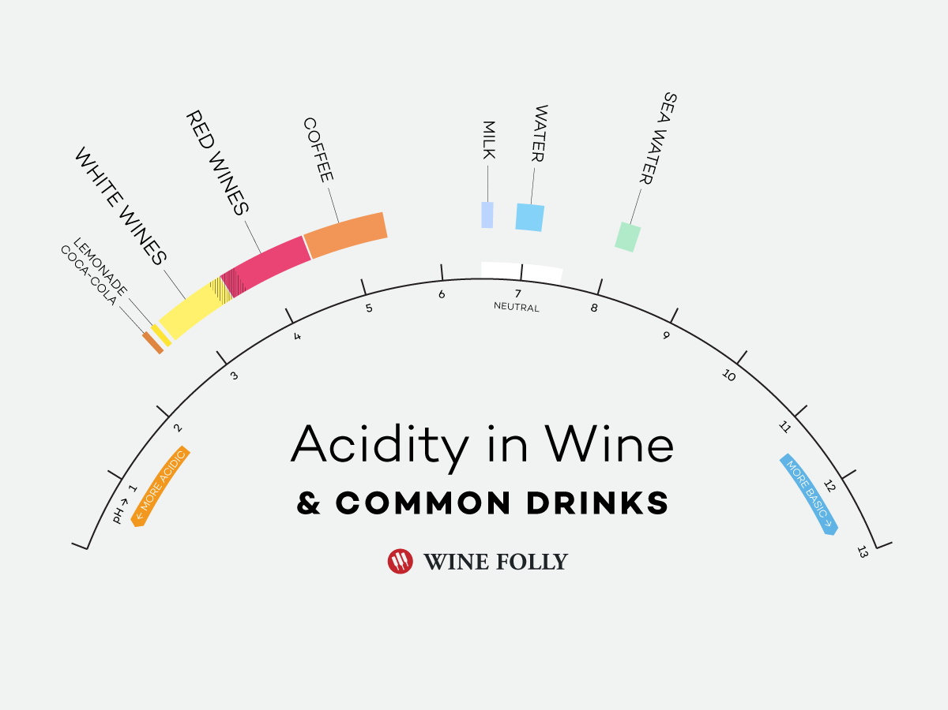

**Conclusion**

The goal of our project was to achieve a recommendation system that consumers and the food industry would be able to utilize. Although taste and preference are subjective, our goal is to improve meals with a sensational wine that heightens satisfaction. We learned the importance of cleansing data in order to discover different patterns to help us resolve our business problem. We also learned that the acidity and ph levels are key determining factors if a food item and wine should be paired together. Understanding the relationship between tannins, acidity, and taste are essential when it comes to wine pairing. This will allow consumer’s experience while dining more enjoyable and their kitchen to become their favorite room in their home.

**References**

* 1. “Natural Language Processing” Elizabeth Liddy, 2001. <https://surface.syr.edu/cgi/viewcontent.cgireferer=https://scholar.google.com/&httpsredir=1&article=1019&context=cnlp>
  2. <https://www.stitchdata.com/resources/data-transformation>
  3. <https://medium.com/@armandj.olivares/building-nlp-content-based-recommender-systems-b104a709c042>
  4. <https://docs.microsoft.com/en-us/power-bi/transform-model/dataflows/dataflows-machine-learning-integration#azure-machine-learning-integration-in-power-bi>
  5. <https://docs.microsoft.com/en-us/azure/machine-learning/tutorial-first-experiment-automated-ml>
  6. <https://winefolly.com/deep-dive/what-is-wine/>
  7. <https://search.ebscohost.com/login.aspx?direct=true&AuthType=ip,shib&db=aqh&AN=97015104&site=eds-live&scope=site>
  8. <https://grapecollective.com/articles/food-and-wine-pairings-art-or-science>
  9. <https://winefolly.com/wine-pairing/what-wine-goes-with-chicken-and-poultry/>